## Understanding the microscopic simulation mechanism using GMNS and DTALite v0.5

Data set

[DLSim/release at main · asu-trans-ai-lab/DLSim · GitHub](https://github.com/asu-trans-ai-lab/DLSim/tree/main/release)

## Learning Goal:

Levels of modeling elements:

|  |  |  |
| --- | --- | --- |
| Category | Lement | GMNS file names |
| A | Network | Node.csv, link.csv |
| b | Demand | input_path.csv |
| c | Signal | timing.csv, |
| D | Scenario | Setting |
| E1 | Link output | link_performance.csv, |
| E2 | Path output | path.csv |
| E3 | Agent output | agent.csv |
| E4 | Trajectory output | trajectory.csv |

## 1. Network Generation

Export map.osm from OpenStreetMap and use osm2gmns to generate node.csv and link.csv with GMNS format for complete network. Then, use net2cell to generate cell based microscopic network.

Testing scripts

[GitHub - asu-trans-ai-lab/osm_test_data_set](https://github.com/asu-trans-ai-lab/osm_test_data_set)

[osm_test_data_set/loop_101.ipynb at main · asu-trans-ai-lab/osm_test_data_set · GitHub](https://github.com/asu-trans-ai-lab/osm_test_data_set/blob/main/loop_101.ipynb)

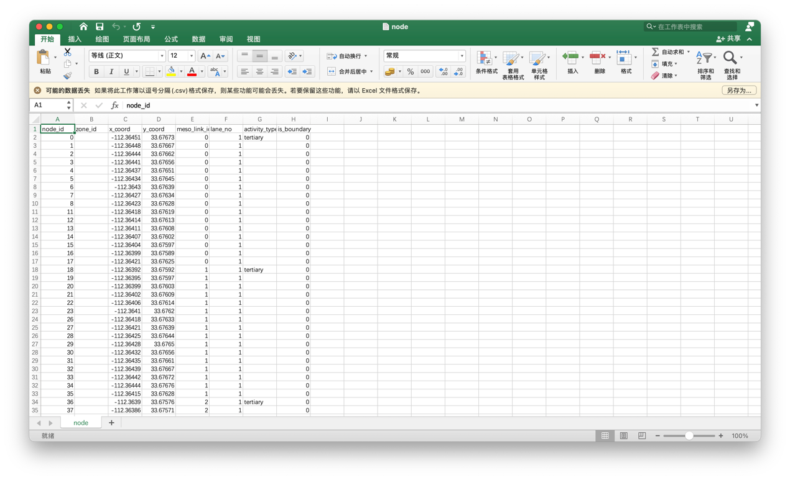

Fig. 1 node.csv

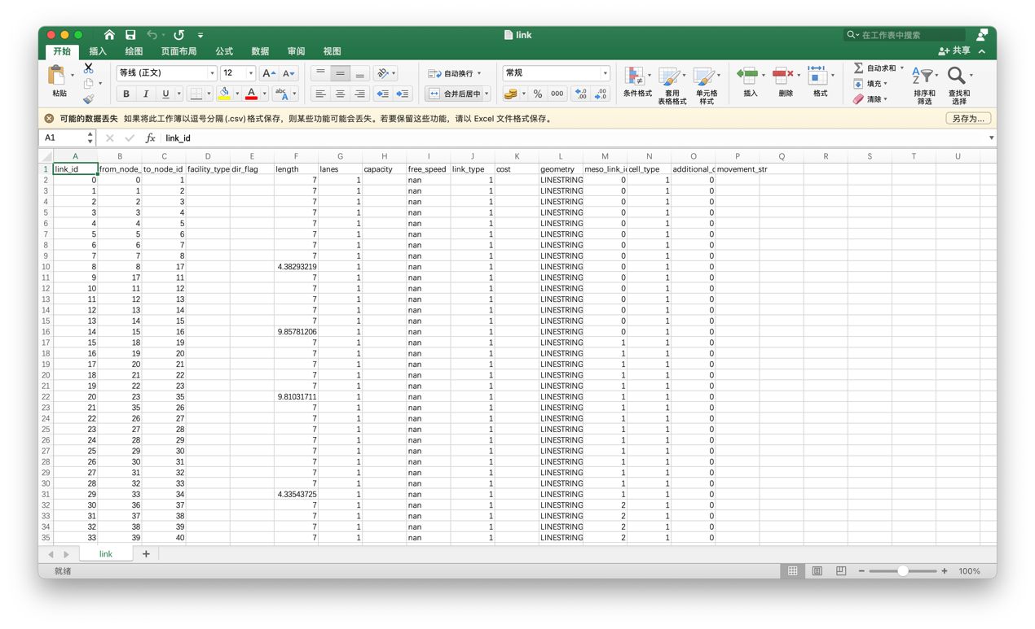

Fig. 2 link.csv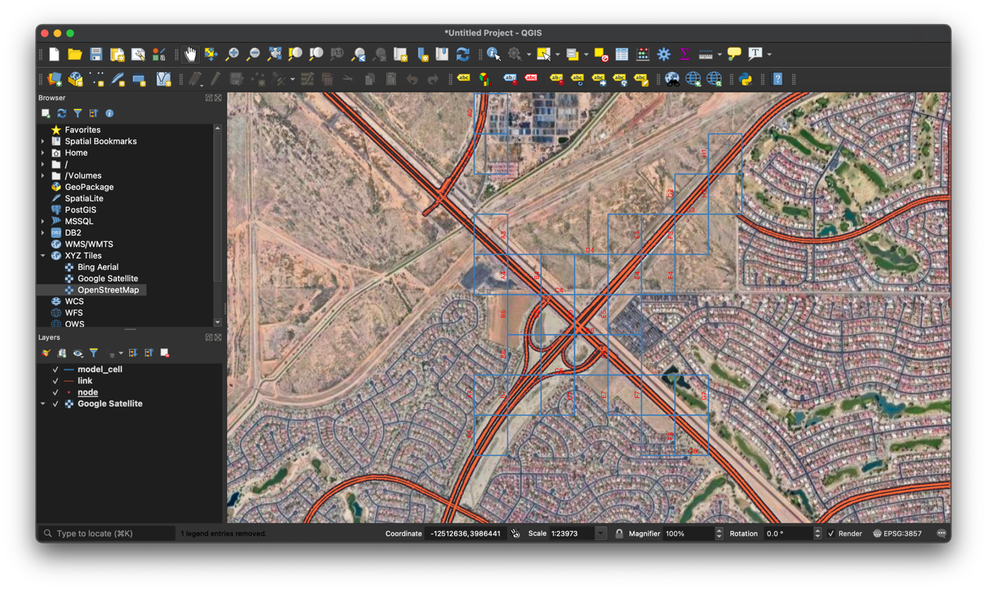

Fig. 3 visualization in QGIS

Here are some steps to process network information.

1. Change the unit of length (from meters to km) in link.csv.
2. Give default values of free_speed, capacity and vdf_tt in link.csv.
3. Lane change penalty in link.csv.
4. Use model cell_code to select subarea node.csv and link.csv.

Select a subset of nodes within the defined cell_codes, e.g. A3, A4, B3, B4 and use VLOOKUP to screen the nodes and from_node_id, to_node_id in links.csv

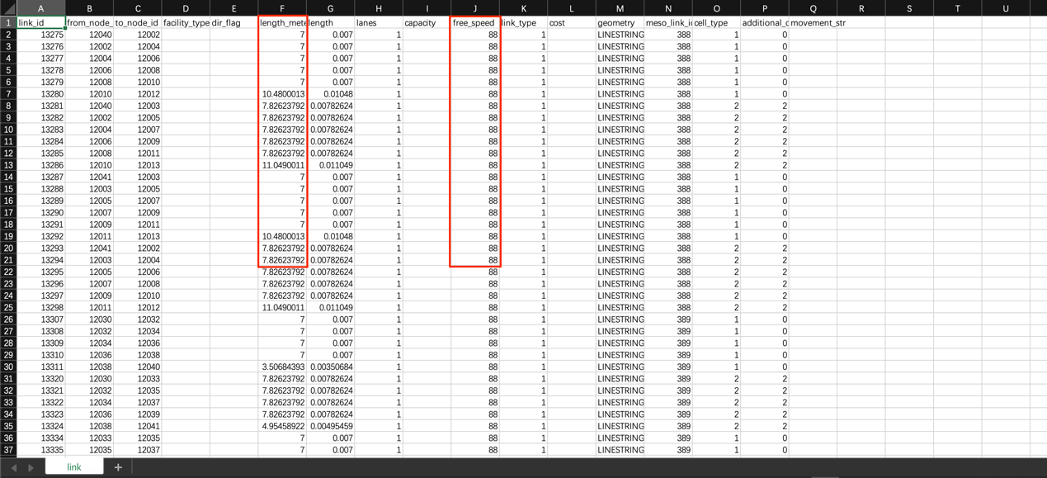

Fig. 4 modification of link.csv (need to further improvement)

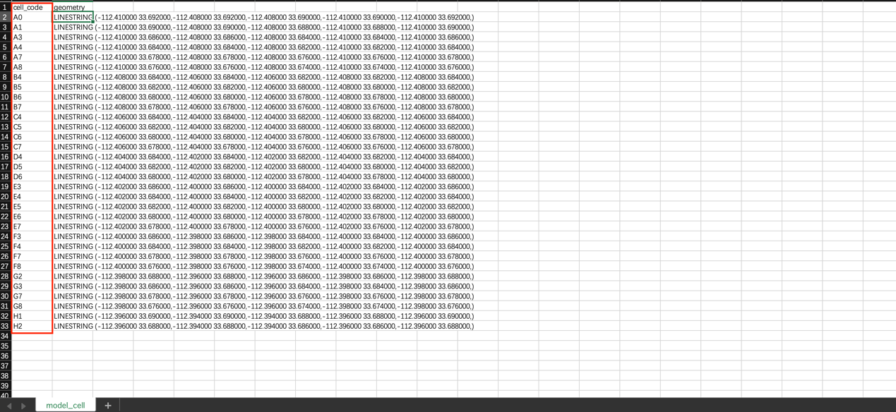

Fig. 5 model_cell.csv

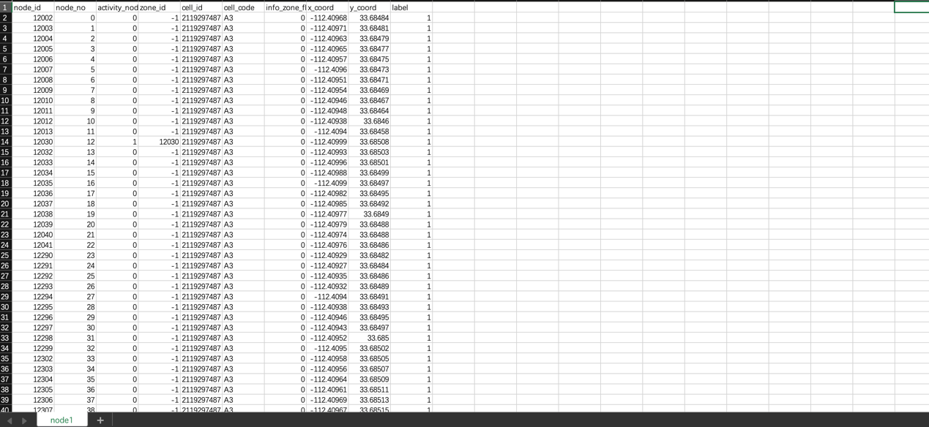

Fig. 6 selected node.csv

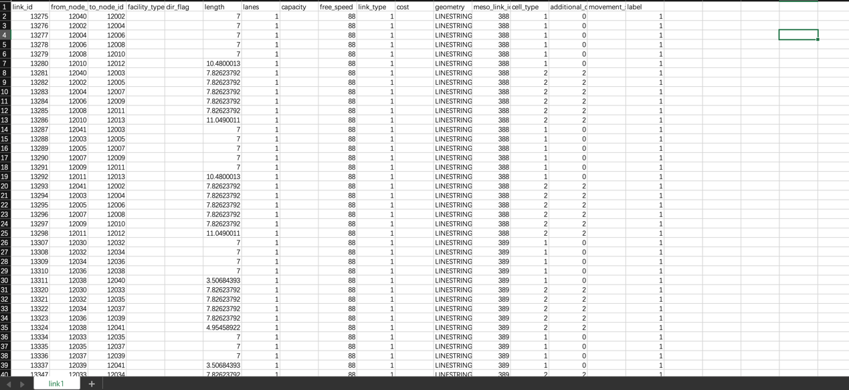

Fig. 7 selected link.csv

## 2. Demand Generation

Use trace2route to generate cell based paths based on macro network data. Here are some detailed steps.

* Obtain input_agent.csv from the macroscopic regional network from or GPS traces
* Use trace2route to generate the map matched sequence in output_agent.csv
* Rename output_agent.csv to input_path.csv add path_id field, according to settings.csv and add fields, o_zone_id, d_zone_id as the node numbers
* Add values for zone_id for those selected origin and destination nodes in input_path.csv

**(DTALite computes shortest path trees for all zone-to-zone pairs, other than node-to-node pairs)**

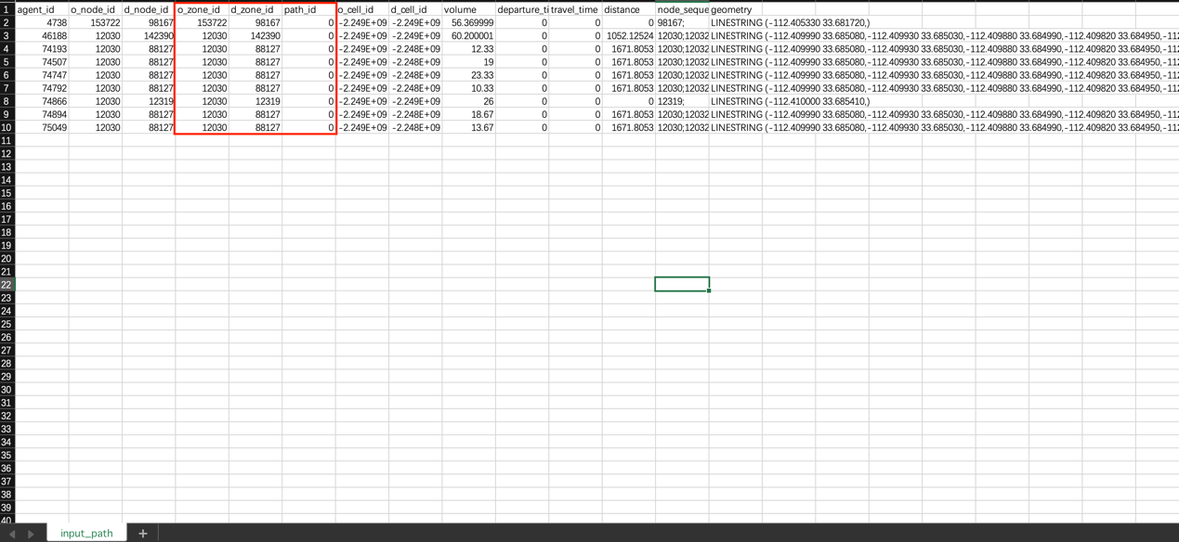

Fig. 8 input_path.csv

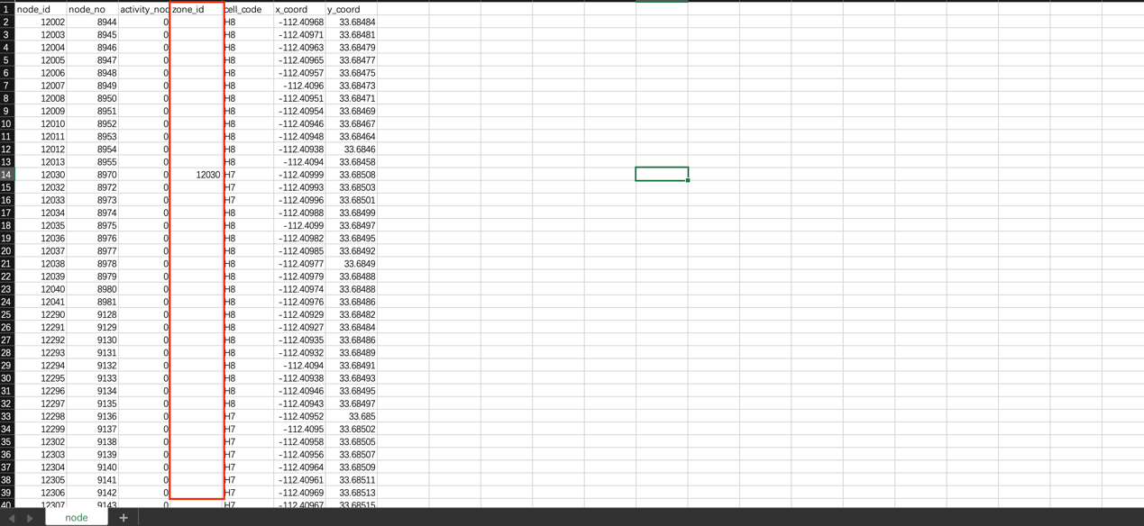

Fig. 9 node.csv

## 3. Traffic Signal

We already have signal control (vol2timing) modules to read the signal timing. Here are main_node_id field and movement field in link.csv. Then, use vol2timing to read timing.csv to simulate signal timing.

## 4. Traffic assignment and simulation

Work on cell-based path. Use 0.1 sec as simulation interval and simple spatial queue (CA). in addition, we also need a simple strategy to determine reaction time tau to consider time-dependent speed reduction.

Run DTALite.exe

We could obtain some key information about traffic assignment simulation, such as assignment mode, agent types, link types, simulation time period, input file name, file format and so on in setting.csv

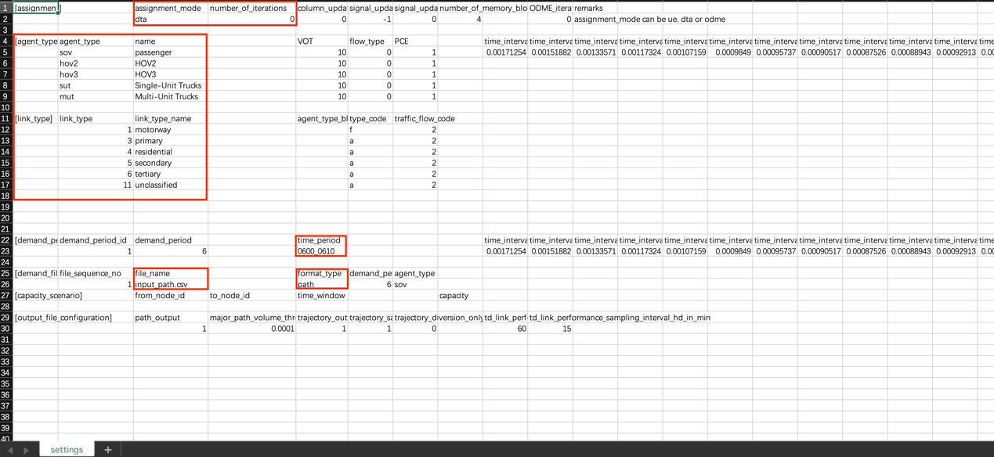

Fig. 10 setting.csv

## 5. Check different levels of input and output

The following input and output files need to be checked systematically.

a. node.csv, link.csv.

b. input_path.csv, timing.csv, settings.csv

c. link_performance.csv, TD_link_performance.csv (link volume, aggregated speed and so on).

d. path.csv (assignment or given input file, both of them need to be visualized in Nexta ->agent diaglog)

e. agent.csv (with different vehicles with different departure times from simulation step (visualized in nexta ->agent dialog)

f. trajectory.csv

## 6. Load node.csv in Nexta

Before Loading node.csv in Nexta, we need to export satellite map from QGIS as an image file. Here are some detailed steps.

Click Project -> click Import/Export -> Export Map to Image…

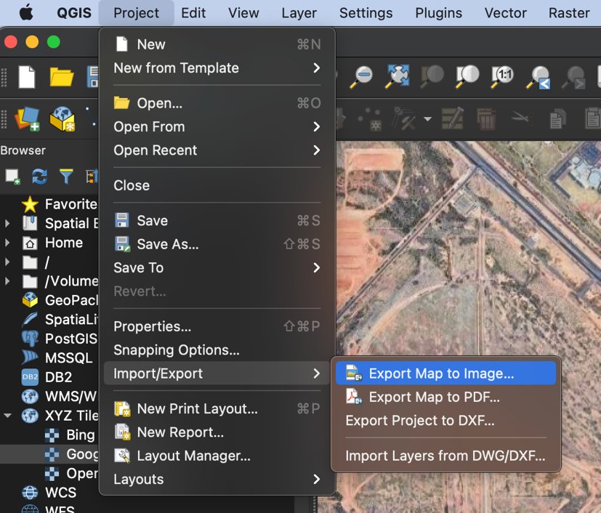

Fig. 11 Export Map to Image

Adjust Resolution to 600 dpi.

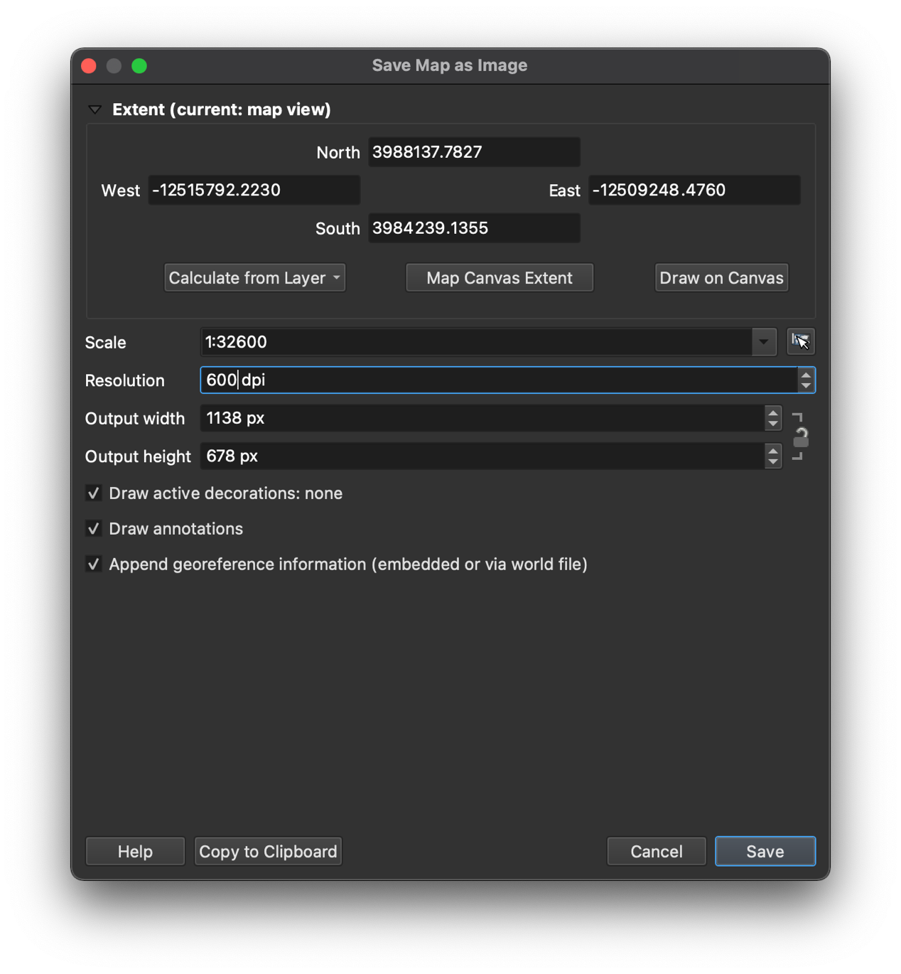

Fig. 12 Adjust the resolution

Then, save this image.bmp in the current directory.

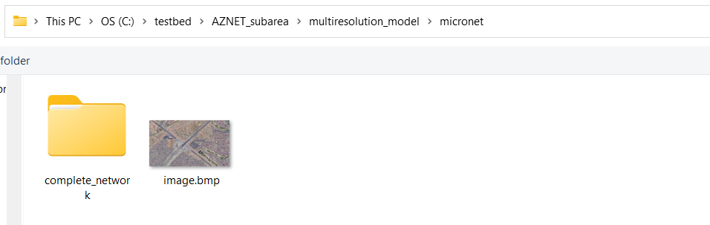

Fig. 13 save it in the current directory

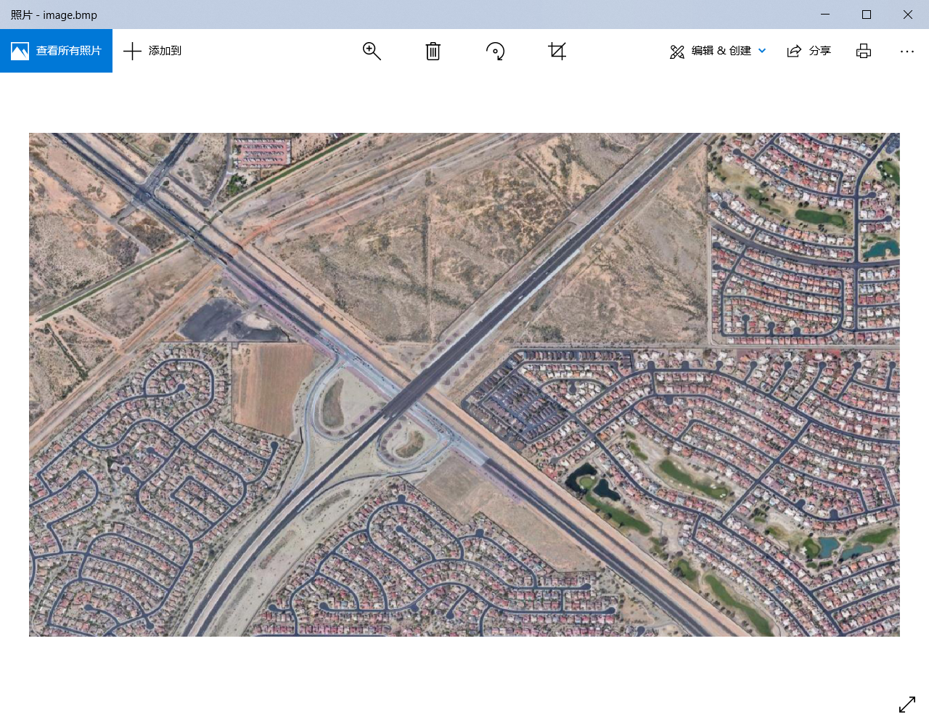

Fig. 14 image.bmp

After that, we could visualize results in Nexta.

We could obtain more information about simulation by clicking on the “agent” button.

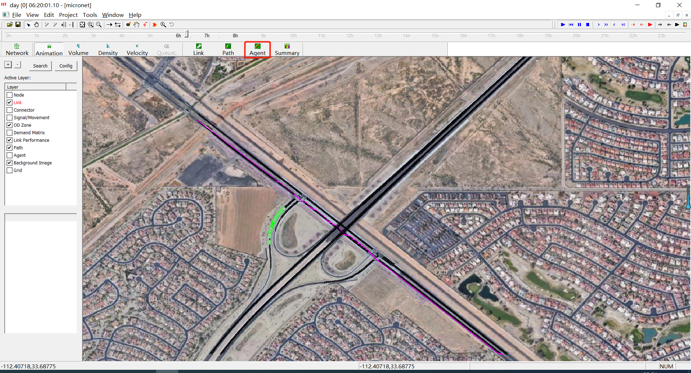

Fig. 15 visualization in Nexta

Then, we could know the OD pair, OD list and path information for this simulation.

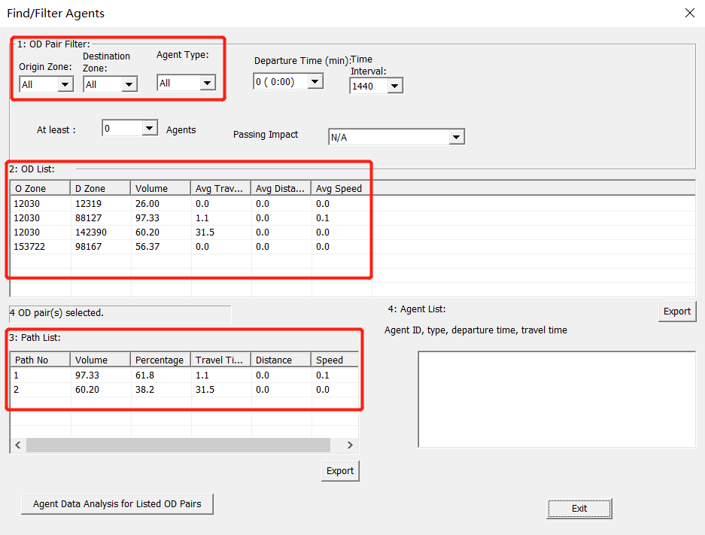

Fig. 16 Agent information

Before visualizing the animation in Nexta, we should set the start time at 6AM (which is marked by red rectangle) because we have already set time period from 6AM to 6h 10 mins in setting.csv.

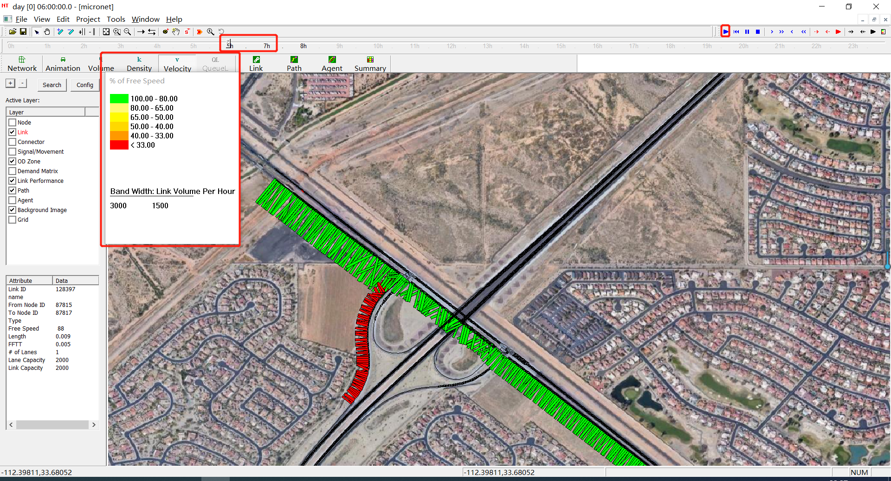

Fig. 17 Simulation in Nexta

## 7. PRIORITY AND CONFLICT AREA

Add node-based logic to consider capacity request and allocation for agents from incoming links, with priority of different types of agents (pax, bike, cars, trucks. Buses).

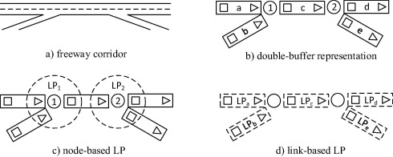

Fig. 18 Priority and conflict

## 8. Trajectory optimization